**GALVEZ, Patrick Louis V. 2023-1-01545**

**C335_IT Oct 28, 2025**

**Laboratory Activity**

**Web Systems and Technology**

**Midterm**

Procedure:

* Open the XAMPP control panel (see image)

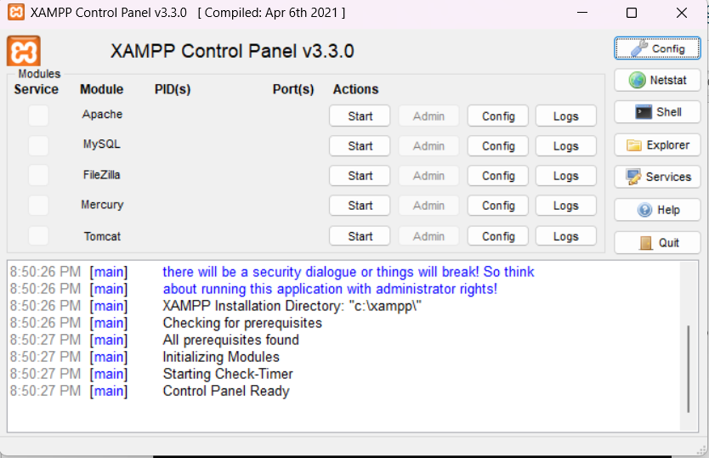

Make sure to click the Start button to open the Apache and MySQL

* Once it green your server is now running

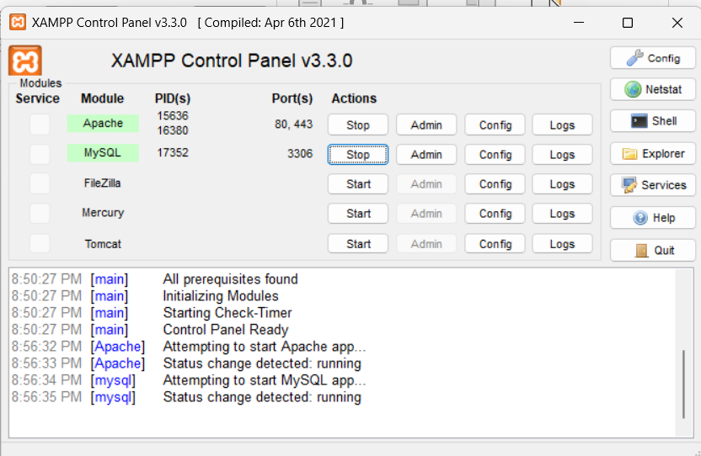

* Make sure to check the ports of Apache and MySQL as follows

* Your now ready to test your server
* Access the XAMPP dashboard in a browser
  + Open your preferred web browser and type http://localhost into the address bar and press **Enter**.
  + If XAMPP is working correctly, you will see the XAMPP welcome page, which confirms the Apache web server is running.

* + Alternatively, you can type http://127.0.0.1 to get the same result.
* Then go to your phpMyAdmin inside your XAMPP control panel (click ADMIN under MYsQL)

* Then it will redirect you to the admin panel

Once open do the following:

* I want you to explore or try to create a sample database as your activity for today.
* Name it on the desired name.
* Screenshot all your works and output in this document and sent it through your github (filename: Activity 3 -10/28 ) this is a different filename from your Activity 2.

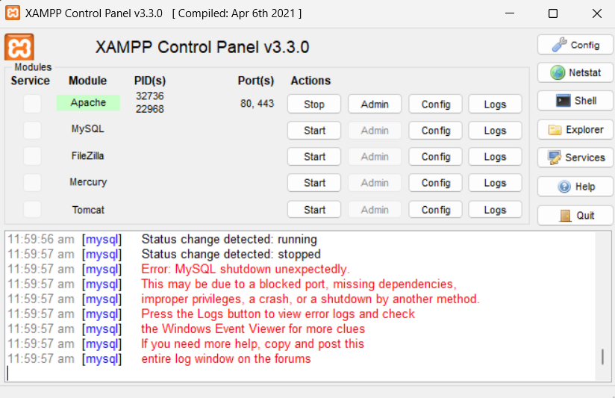

**Finished sample database:**

